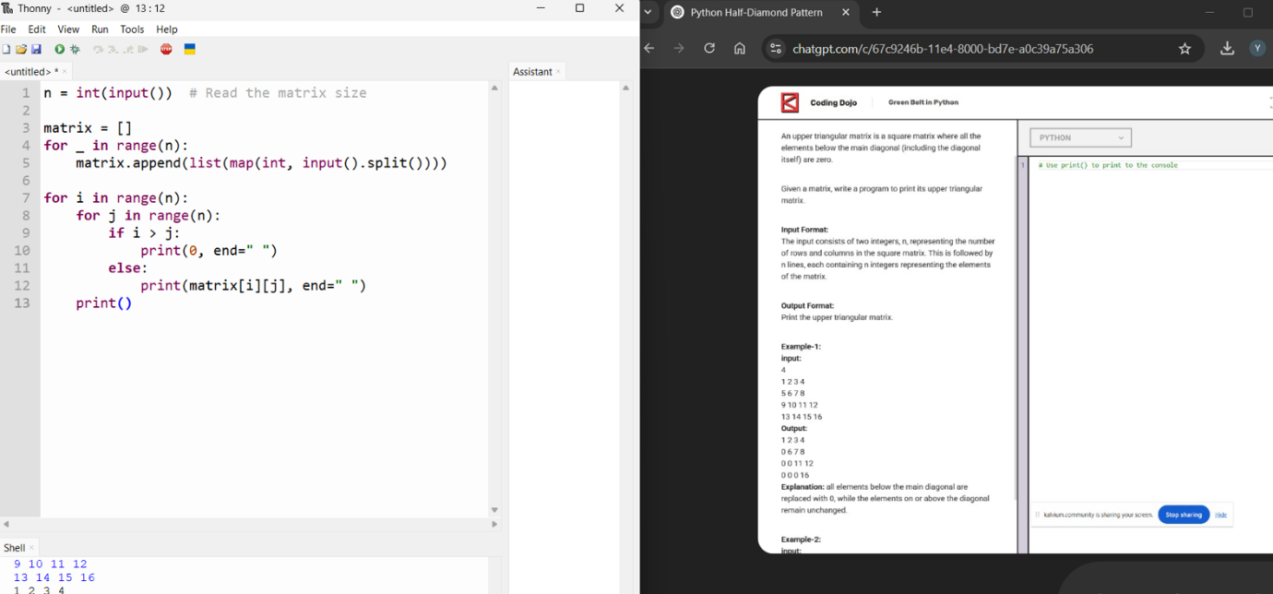
Replace numbers below the diagonal with 0. Print the updated grid.

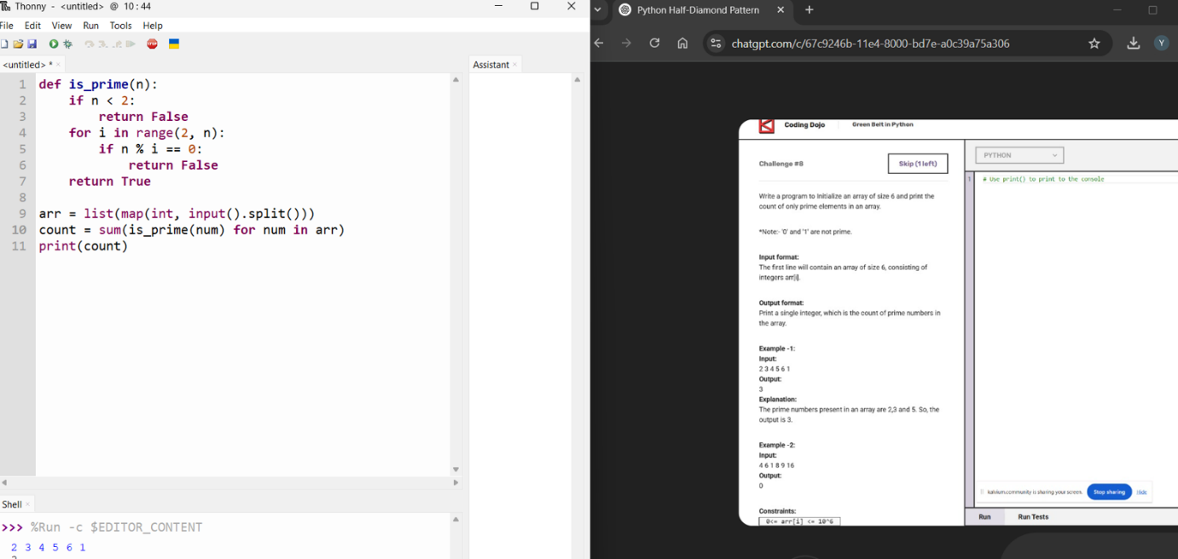
The code checks which numbers are prime. It counts and prints how many prime numbers there are.

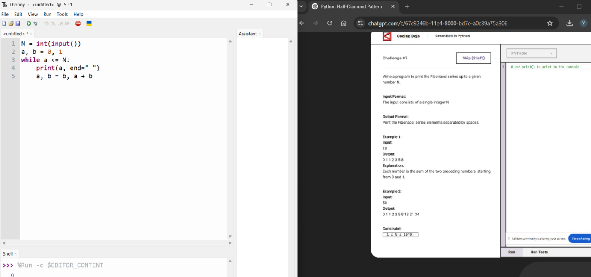
The code prints Fibonacci numbers up to a given number. Each number is the sum of the previous two.

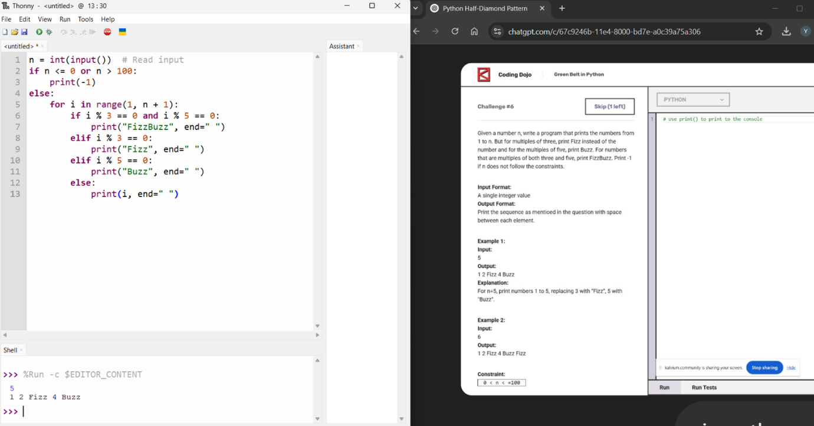

The code prints numbers, but for multiples of 3, it prints Fizz, for multiples of 5, it prints Buzz, and for both, it prints FizzBuzz. If the number is not between 1 and 100, it prints -1.

